**SMMASH3 Infographic Launch Event**

**March 2022**

**Stakeholders Responses – Discussion Summary Report**

*Exploring and responding to the sexual, mental and wider health needs of gay, bisexual and other men who have sex with men in Scotland?*

*Infographics developed in collaboration with NHS Greater Glasgow and Clyde (GGC), NHS Lothian, Glasgow Caledonian University.*

*Infographic Launch event support by NHS GGC, NHS Lothian, Glasgow Caledonian University, REACH (Research Centres for Health) and Waverley Care.*

**Introduction**

**Background**

SMMASH (Social Media, Men who have sex with men, Sexual and Holistic Health study, <https://www.smmash2020.org/>) is longitudinal survey which is delivered online to look at the sexual, mental and wider health of gay, bisexual men and other men who have sex with men in Scotland, Wales, Northern Ireland and Republic of Ireland. The survey has been carried out every three years from 2013 (SMMASH) with SMMASH2 in 2016 and SMMASH3 in 2019. An additional survey (SMMASH Pan) was carried out during 2020 to looking specifically at health and wellbeing during the first COVID-19 national lockdown.

SMMASH3 is the third triennial research study investigating both the sexual health and broader general health and wellbeing of a gay, bisexual and men who have sex with men in Scotland. This research is one of the key mechanisms enabling both the academic and health sectors to assess the health and social care needs of this key population group.

**Infographics**

A partnership consisting of Glasgow Caledonian University, NHSGGC and NHS Lothian have translated the most recent research report (December 2020) into a series of infographics. The infographics have been designed to summarise the key findings and support a range of stakeholders to share, discuss and respond to these findings.

**Launch Event**

A range of stakeholders from across the third sector, academia, public sector and communities were invited to attend the launch of the SMMASH3 Infographics to explore and respond to the key findings and consider the key actions which need to be address in response to the SMMASH3 findings. Event participants were invited to take part in focused discussion groups to explore, discuss and respond to the key findings highlighted in the infographics including:

* HIV and STI Testing, PrEP (Pre-exposure prophylaxis) & Condoms, Living with HIV
* Mental Health, Alcohol and Drugs, Men in Relationships
* Young Men, Sexual Wellbeing and Sexual Activity, Social Media

**Report Overview**

This report presents the key discussion points from each of the short discussion groups. While each group was facilitated, it is acknowledged that within these groups some focused on one particular infographic or key finding while others discussed wider findings from SMMASH3. This opportunity allowed stakeholders to consider the key findings relevant to their role however this means that each section of this report has a different approach. In addition, the responses highlighted in this report provide a summary of stakeholder discussions from the eventand not the findings from SMMASH3. This report is not intended to be representative of all organisations involved in the event and does not represent all organisations suggested actions.

**Report Aim**

This report intends to provide a summary of the discussions from the launch event with stakeholders, providing an overview of stakeholders responses and their suggested key actions in response to the key findings and infographics. It is acknowledged that this only represents the discussion from stakeholders attending the launch event and that wider discussion is required to explore and suggest actions in response to the SMMASH3 findings.

This report is intended to continue the discussion from the launch event and support stakeholders to consider the responses and their role in shaping and taking forward actions they suggested.

**Part 1: Summary of discussion in response to the SMMASH3 Infographics – HIV and STI Testing, PrEP and Condoms, Living with HIV**

**Appropriate Testing**

* Consider awareness of what is ‘appropriate testing’ and what is meant by low or high risk sex
* Challenge around terminology (low or high risk sex)
* How do we translate it into a toolkit usable for men?

**Differences in Testing Behaviours**

* Opportunity to explore testing behaviours across age group. Acknowledgment that current testing may not be reaching younger men, those not using these apps or those financially worse off or less educated.
* Specific message targeting higher risk men: There is a need to encourage routine testing for all and understand reasons why some men are not testing (where appropriate).
* Lower testing rates amongst bisexual men and those in relationships with women. There is a continual challenge in reaching them with information about testing and broader sexual health.
* Importance of identity for men and need to think more about it in how we market and communicate testing services and messaging.
* STI testing higher for HIV positive men: perhaps part of annual health check. Is there an opportunity for this to be developed as a positive way to encourage testing?

**Testing Capacity and Accessibility**

* Need to consider whether they were able to test 3 monthly i.e. is service capacity there to accommodate 3 monthly testing?
* Testing capacity could be a possible factor
* How accessible are testing services? How available are they to people who work during the day or those outside cities?

**Testing Awareness:**

* Opportunities to target younger men around testing
* Do sexually active men generally know about the importance of testing regularly and what more can we do?

**Section 1: HIV and STI Testing, PrEP & Condoms, Living with HIV**



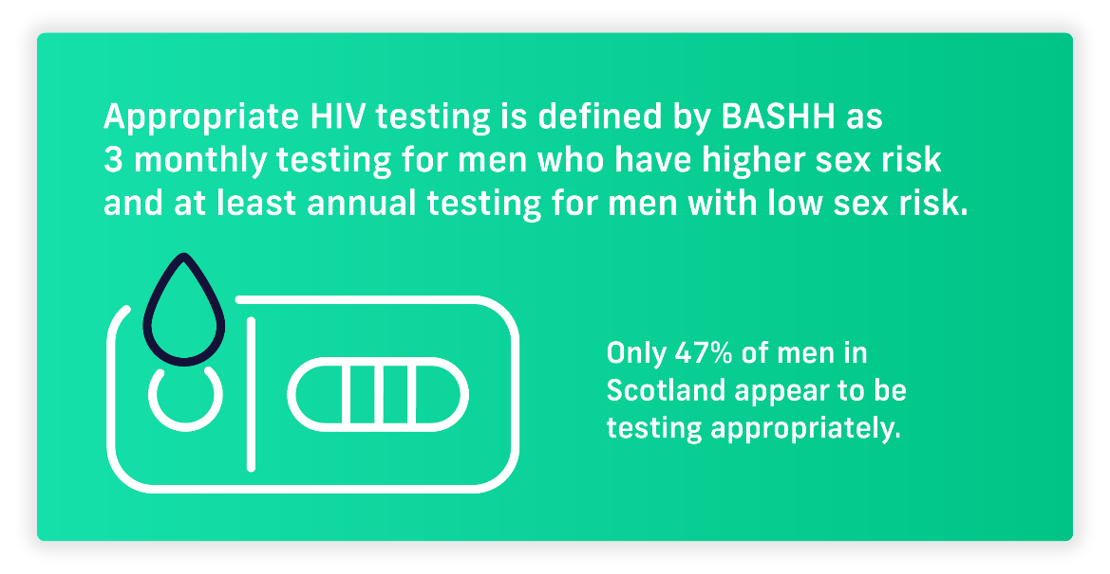

**PrEP**

* Why are those who are interested in PrEP not using currently? How much do they really know?
* Is access an issue? Is eligibility criteria a barrier?
* It needs to be promoted including awareness of methods of use for example get it now to use it later.
* Wider consideration on availability of PrEP
* Findings highlight differences in uptake in PrEP between different age groups. What can we do to reduce resistance to PrEP amongst older gay men? Do we need to do some myth busting around PrEP?

**Condom Use**

* Lots of challenges around young men and condoms. Need more information so young men know about free condom schemes and how to access them.



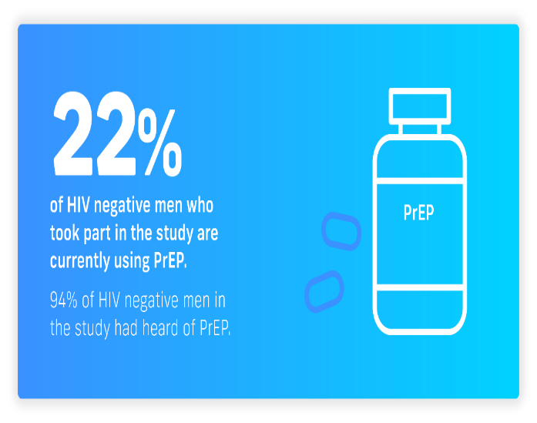



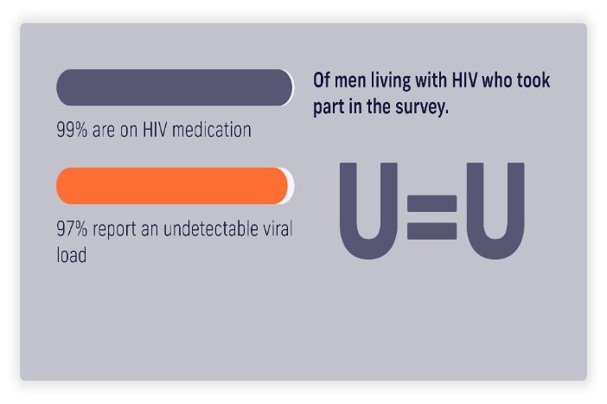

**Living with HIV:**

* Lack of general awareness of the success of getting people onto medication and huge benefits of treatment
* Further work required to promote the benefits of treatments could encourage wider testing.
* Care needed to consider stigma
* U=U (Undetectable=untransmissable) not as widely known as could be. Work is required to increase understanding and awareness. This and other issues could be put into relevant training and education programmes

**Part 2: Summary of stakeholder discussions on suggested key actions - HIV and STI Testing, PrEP and Condoms, Living with HIV**

**HIV and STI Testing**

* Regular testing campaigns that focus on young people
* Promote regular trips to testing centre?
* Pop up testing centre in a youth spaces e.g. at PRIDE youth space
* Review how we communicate to GBMSM about testing given we are missing a significant percentage
* Explore opportunity to have some self-test kits in the youth space
* Opportunities to offer and expand community testing

**PrEP and Condom Use**

* Increase access to PrEP and information regarding PrEP to younger people 16-25
* Ensure PrEP provision resource available
* Research would be beneficial to explore the reasons why people who say they would take PrEP in the future are not at present.
* Research-wise, exploring decentralizing PrEP availability into the community would be a key area of focus.
* Explore how we can engage with young people to effectively uptake the Free Condoms service within NHSGGC
* More work to explore younger people and condoms

**Living with HIV**

* Find out more about the issues for men living with HIV.
* Do we have the right support for people living with HIV?
* Need to know more about why there are more casual partners for men living with HIV

**This discussion group also consider the key findings around HPV:**

**HPV**

* Findings highlight a difference in HPV vaccine between those living with HIV and wider population.
* Incorporate HPV vaccines in other services or through outreach HPV vans
* HPV vaccine take up and awareness opportunity to test platforms such as TikTok to measure and impact of some of the areas identified as development opportunities

**Part 3: Summary of stakeholder discussions around who should take forward actions?**

**Education (Further Education and Training Providers)**

* Incorporate these findings into relevant modules in nursing training/education programmes/courses at all levels to increase awareness and understanding around the key messages for example U=U
* Incorporate findings in relevant training programmes for staff across health and social care

**Research**

* What can we do to ensure BAME communities are included in the research?
* Research needs to be developed to understand different experiences of different communities
* Consider the gaps in the current research for example young people, specific population groups

**Communities and Community Organisations**

* Explore opportunities to share findings with organisations that support BAME communities
* Support specialist services to provide outreach into different areas of the community

**Dissemination and understanding of findings (Event participants and stakeholders)**

* Ongoing consideration of findings and how these relate to current work
* Develop a toolkit – coproduced with range of stakeholders and communities
* Understanding the gaps

**Services/Organisations (including both the public and third sector)**

* Considering the relevant networks for these findings and ensuring working better together.
* Consider how can we use technology to support communication of key messages and information
* Consider resources required on PrEP, testing and U=U for outreach work
* Continue to promote and increase awareness of the key issues highlighted by this research
* Consider how do we communicate information about sexual health, testing and condoms
* Consider where people get their specific health information and consider the gaps in information/accessibility of information
* Prioritising and demonstrating through evidence base - correlating with work plans and workstreams.

**Part 4: Within this discussion group, a number of stakeholders suggested the key actions they would take forward:**

**Clinical Services**

Within the clinic continue to get MSM to think about sexual behaviour and subsequent benefits of taking PrEP, resources to be accessible

**LGBT Youth Scotland**

Find out more about what your young people's knowledge level is about all of these areas (HIV testing, Prep, U = U) and then designing some digital information sessions around that.

Develop training opportunities for staff and volunteers supporting young people for example via Live chat

**NHS Health Improvement Teams**

Explore how the findings of this and other research are embedded within team work plans

**Waverley Care**

Develop work to explore myth busting around PrEP - PrEP misconceptions that might need challenging, increased awareness of appropriate testing options/timelines

**Section 2: Mental Health, Alcohol and Drugs, Men in Relationships**

**Part 1: Summary of discussion in response to the SMMASH3 Infographics** 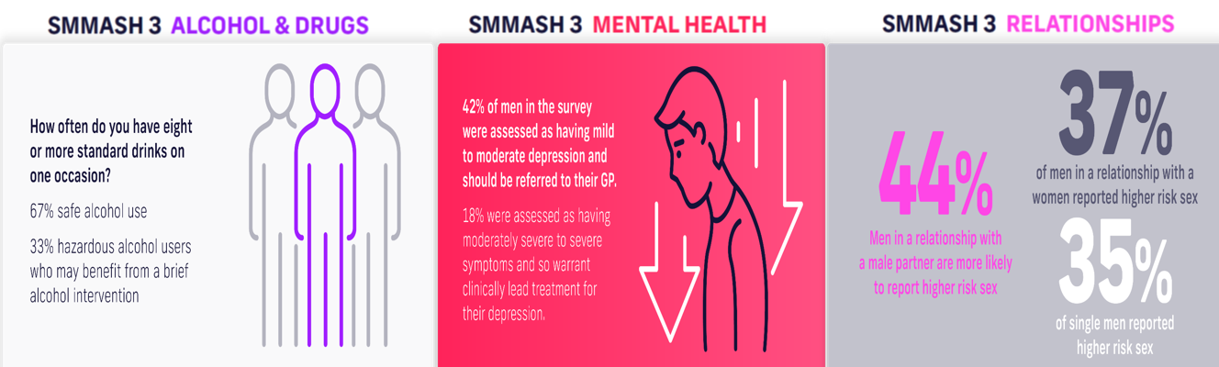

**Key Themes – Highlighted and Explored\***

* Acknowledgement and awareness of these issues
* Prescribing medication can be seen as an immediate resolution but is not always conducive to the wellbeing of LGBT+ individuals.
* Highlighted need to considering root causes and the need for change
* On apps like Lex and community groups on Facebook from time to time, some people actively looking for medication because of barrier around negative experience accessing support.
* In homelessness services there is still a significant gap in terms of developing awareness as well as a framework for intensive support and collaborating with other services to optimise management of LGBT health and wellbeing
* Issues around stigma are so important to consider. There is lots of research around people in marginalised and minority populations perceiving and experiencing stigma and discrimination within health and social care settings. Is there an opportunity to develop and deliver some 'unconscious bias' training?
* If we are to look at joined up work when developing training we need to ensure that we explain why GBMSM are more likely to have poor mental health or issues around alcohol and drugs. e.g homophobia, heterosexism
* Consideration required around how open relationships are discussed. These should be discussed openly and positively (by all relevant services).
* Appreciate every MSM is different, not one solution for all

*(*Please note: The topics is section 2 where discussed together and there for the key themes have been presented together)*

**Part 2: Summary of stakeholder discussions on suggested key actions**

**Capacity Building**

* Develop clear positive messaging.
* Coproduce toolkit for community groups and individuals to use to build their capacity and confidence.

**LGBT Awareness and Training**

* Incorporate key elements into training and education sessions and raise their profile
* LGBT+ awareness from an early age. Start the conversation early. Increase LGBT+ awareness sessions in schools. Opportunity to continue to review and updated Relationship, Sexual Health and Parenthood Framework.
* Raising awareness across all health and social care workers
* Training for primary care practitioners around LGBT.

**Partnership Working**

* Emphasis on collaboration and a collective approach including sharing information, how to provide support between organisations
* Explore how organisations, workforce and communities can work more effectively together to work out what actions are required and how to deliver.
* Enhance partnership, greater awareness of other services and effective signposting

**Support and Supportive Spaces**

* Screening questions for mental health and substance misuse in relevant services where people engage for example Sexual Health Services
* Promotion of social groups and support for LGBT+ health and wellbeing
* Creating and supporting peer support spaces that challenge dominant cultures (e.g. sober, discussing mental health and challenges)
* Creating an app for LGBT+ people experiencing domestic abuse to offer advice or to report domestic abuse incidents.
* Engaging with the private sector to create sober spaces, more mental health support. The focus is normally on the public sector and 3rd sector services.

**Further research and exploration of findings**

* Further research into the causes of depression and anxiety amongst MSM to support and plan relevant actions and services.
* Ensure findings are used for future planning
* Continue to seek opportunities to hear voices of those who are missing from these findings

**Part 3**: **Summary of stakeholder discussions around who should take forward actions?**

* Organisations or and individuals with lived experience and working with LGBT BAME community.
* Public and voluntary
* Education and Universities
* Private sector

**Section 3: Young Men, Sexual Wellbeing and Sexual Activity, Social & Sociosexual Media**

**Part 1: Summary of discussion in response to the SMMASH3 Infographics**

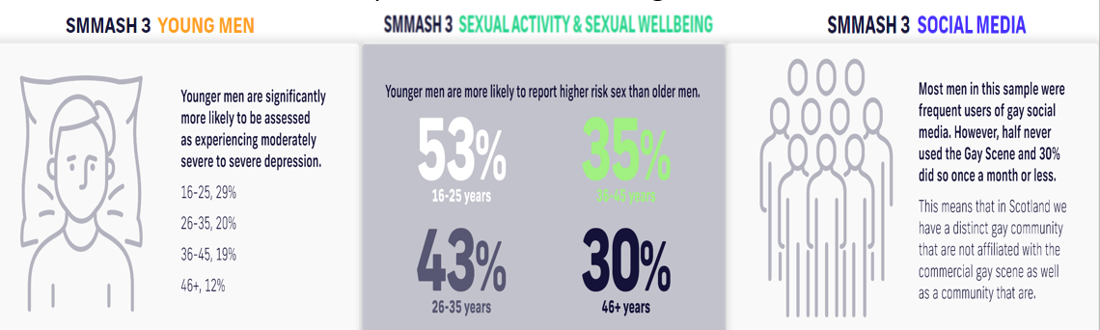

**Key Themes – Social Media**

* Socio sexual apps and websites are used for outreach, which can have its challenges with engagement.
* *SX* have noticed a quieter period on social media and apps. Perhaps explore how this has differed between 2020 and 2022?
* People are on social media a lot, and people want information from safe sources.
* Consideration that outside of the metropolitan areas, there is little to no “gay scene”, therefore online apps and social media is the “gay scene”.

**Key Theme – Yung Men**

* Engagement around key transitional period:
* PrEP usage is lower in young men? Exploration of reasons
* Prevention is better than cure. Early, comprehensive, LGBT+ inclusive sex, drugs and relationship education to support young people.
* Acknowledgement of Relationship, Sexual Health and Parenthood Framework (RSHP) and ongoing developments with education to ensure inclusive programme.
* Youth settings may give an opportunity to engage with young people not engaged through school programme.

**Key Themes – Sexual Activity and Sexual Wellbeing**

* Further exploration around sexual activity would be interesting in terms discussions with partners including confidence relating to suggesting or refusing sex.
* Would be interesting to see how findings on sexual problems and sexual dysfunction compare with heterosexuals in nationally-representative surveys
* High risk sex - Consider discussion regarding normal risk behaviour versus harmful risk taking in young men.
* Counselling services - Acknowledgement limited resources and no short term solutions.

**Part 2: Summary of stakeholder discussions on suggested key actions**

**Sexual Activity and Wellbeing**

* More in depth research into how different topic areas differ between gay identifying MSM and bisexual and non-identifying MSM.
* Workshops and/or videos alongside non-LGBT services (like *I Am Me*) to discuss key topic areas.
* More information on age of first sexual health service attendance and whether this correlate with PrEP usage or awareness?
* Social groups to be promoted (non-club scene)
* How do services evidence contribution to responding the mental health issues. Is there something we can do about EQIA process to make these issues more prominent?
* Lobby the Scottish government for more funding around sexual & psychological health support services. Consideration of whether there is enough of a strong voice at government funding level?

**Young Men**

**Further research and identifying gaps**

* Why are young men more likely to participate in high risk sex? Are there further questions relationships and “feeling safe”?
* How and where are young men socialising? We need to go to them, and incorporate all aspects

**Widening engagement**

* If young men are in general more risky, but less likely to access services, is there something fundamental about how we design services that needs to change?
* Do we refocus on engaging in more informal setting for example, youth groups
* Do we have sufficient mental health interventions for young GBMSM and are they inclusive?
* A "gaps" infographic would be useful including "what we don't know" and "what needs improved"

**Increasing Awareness and promoting key messages**

* More information to be provided on social media and gay apps, particularly for young men.
* Targeted advertising and promotion on apps that young men are using – Tiktok, Snap Chat.

**Social Media**

* With 20% using Tinder, is this an underutilised app for advertising and promotion?
* A one pager to be utilised through club scene with a list of the relevant organisations. Something a young man would pick up and utilise.
* Need for a “digitally, culturally aware programme”. Consider Tik Tok or social media and LGBT bar scene.

**Part 3: Summary of stakeholder discussions around who should take forward actions?**

* **Police Scotland** - Arrange an event with their Public Protection team to further share work of SMMASH3/ needs of GBMSM in relation to their work
* **SX and ROAM** - Social media delivery and targeted advertising in NHS Lothian.
* **National RSHP Group** – Continue to review and adapt programme to ensure this is inclusive